`



SCSJ 1023: Technique Programming II

Assignment 3 : Exercise 2 & 3

|  |  |
| --- | --- |
| NAME | MATRIX NO |
| AHMAD SYAFIQ BIN ANUAR | SX160093CSJS04 |

Exercise 2

1. Content of myArray

|  |  |  |  |  |  |  |  |
| --- | --- | --- | --- | --- | --- | --- | --- |
| 0 | 1 | 2 | 3 | 4 | 5 | 6 | 7 |
| Out of bound | Out of bound | -2 | 12 | 16 | 20 | 24 | 28 |

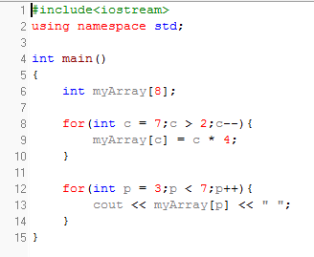

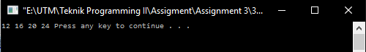

1. Code

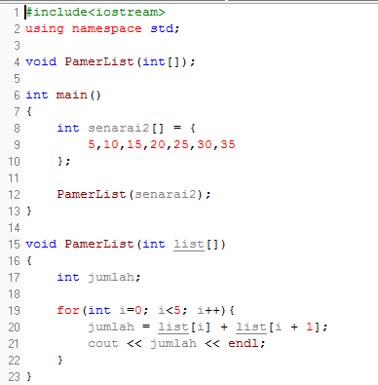

Output

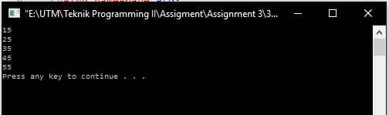

1. Code

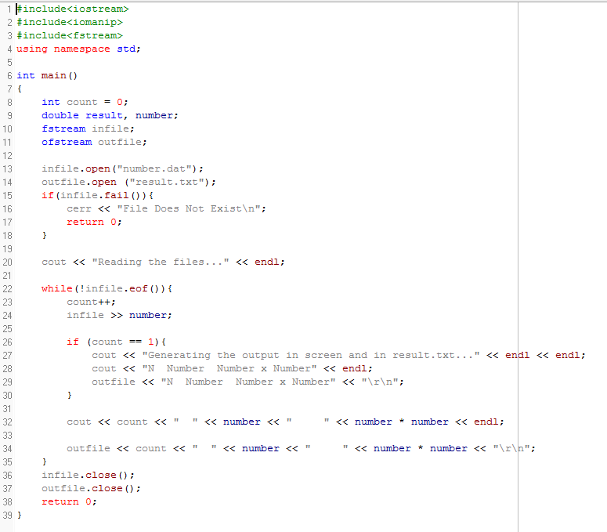

Output

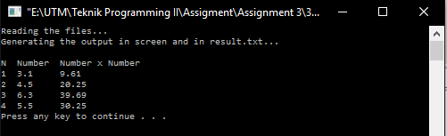

1. Code

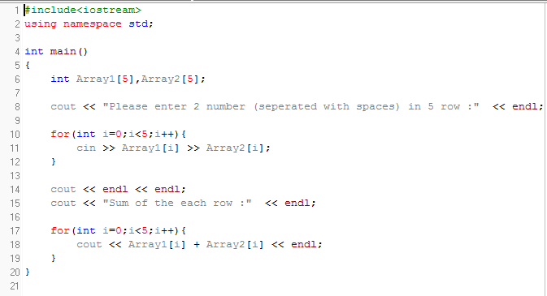

Output

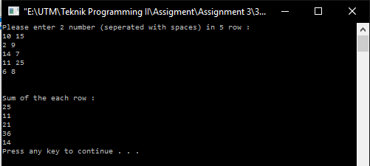

1. Code

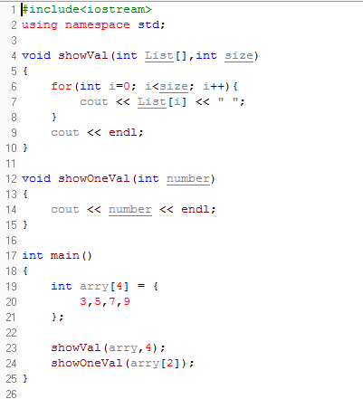

Output

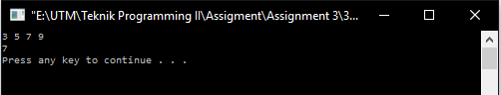

1. Code

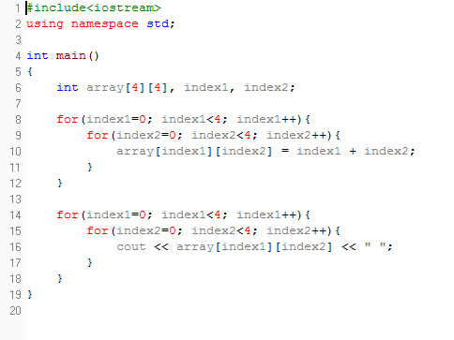

Output

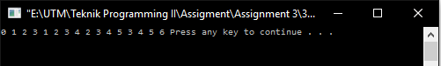

1. Code

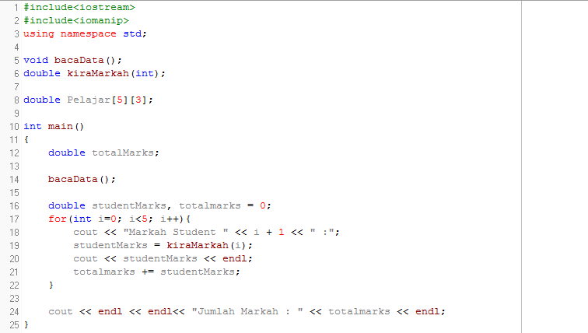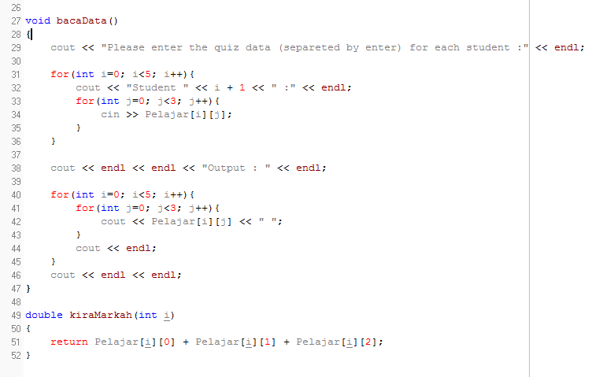

Output

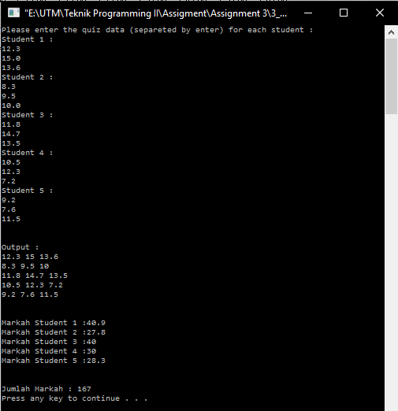

Exercise 3

1. 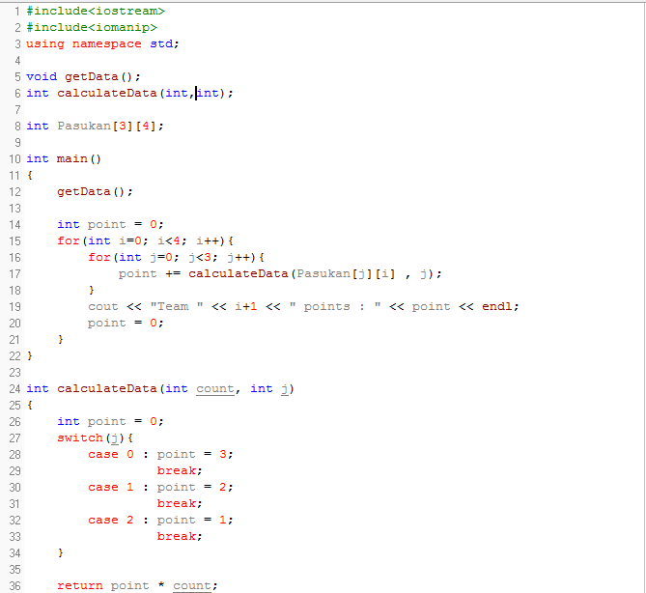Code

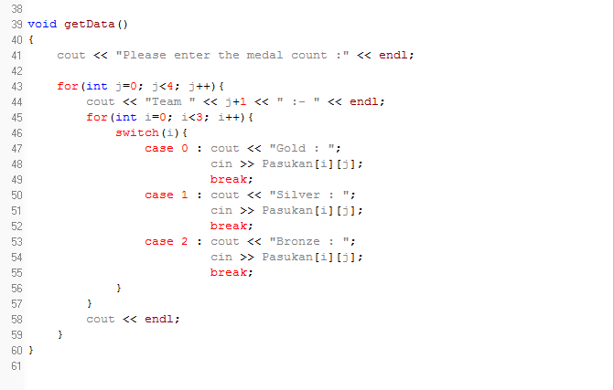Output

